**--Faryal khan Reports**

**Business Report 1**

**Report Name:** All Klaus Brewery Employees located in Houston area

**Report Description**: This report displays employees who have stated ‘Houston’ as their city of location.

**Business Purpose:** Klaus Brewery will use this type of report to understand and analyze number of Employees who are living in the Houston area and how can they better accommodate their employees for Houston Branch.

**SQL CODE**

--Report for employees located in the houston area only

declare

@CITYNAME VARCHAR(25)

select @CITYNAME= 'Houston'

select City.City_ID as'City ID',

City.City_Name AS 'NAME OF CITY',

CITY.Country_ID AS 'COUNTRY ID',

EmployeeInformation.Employee_Id AS 'EMPLOYEE ID',

EmployeeInformation.First_name AS 'FIRST NAME'

FROM EmployeeInformation

JOIN dbo.Zip_Code on Zip_Code.Zip_Code_#= EmployeeInformation.Zip_Code

JOIN dbo.City on CITY.City_Name= EmployeeInformation.City

where CITY.City_Name=@CITYNAME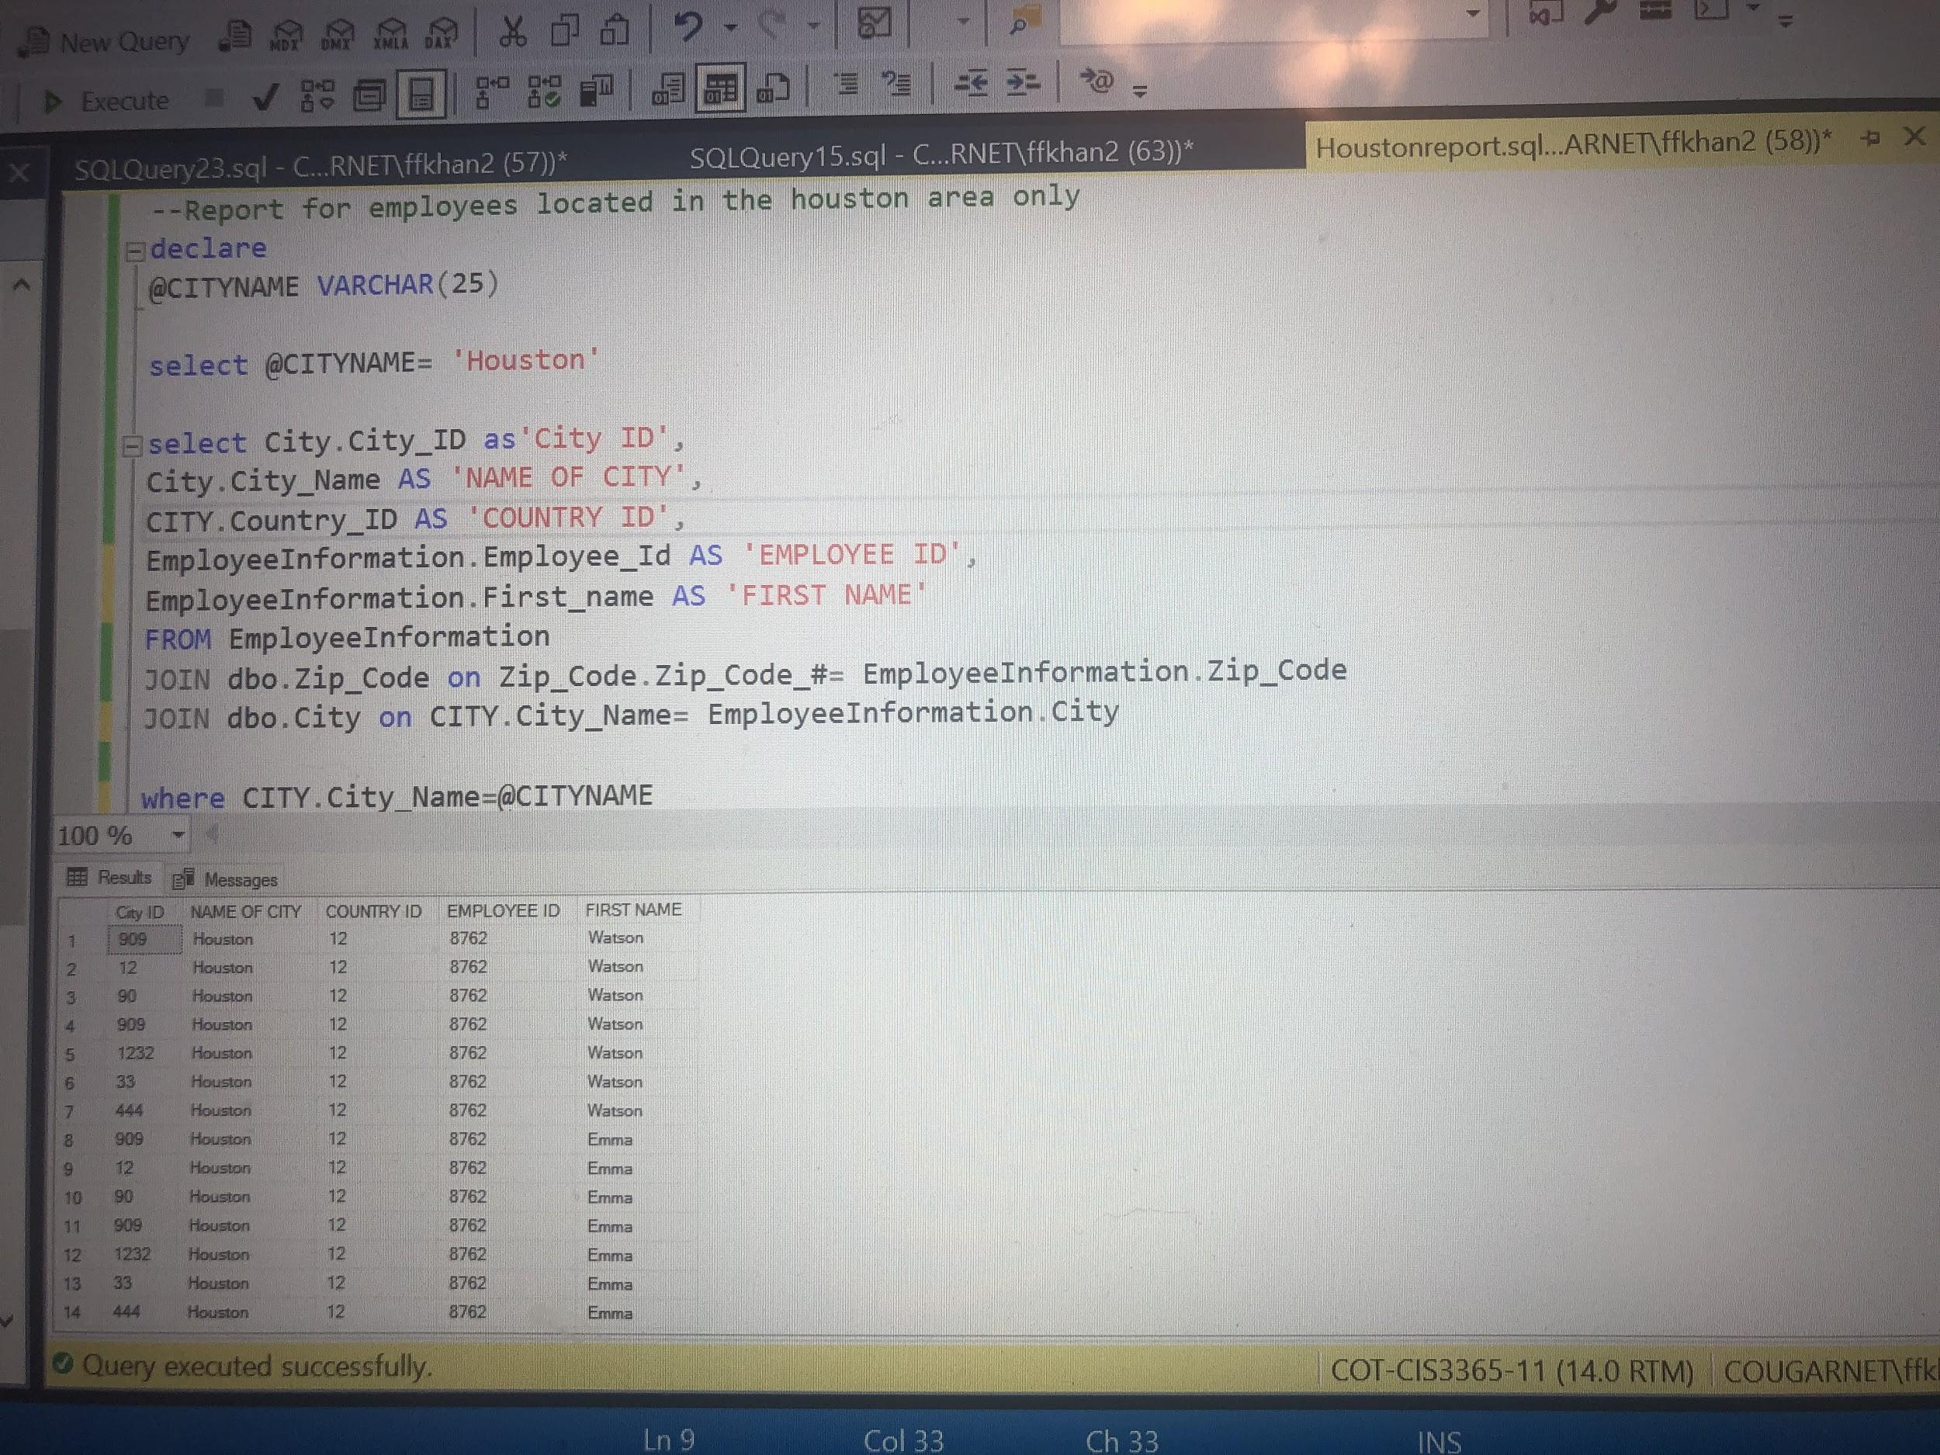

**Business Report 2**

**Report Name:** All Klaus Brewery Glassware that are of 2.8oz capacity.

**Report Description**: This reports displays all glassware for klaus which have a capacity of 2.8oz. These glasswares range from wine glasses to beer glasses.

**Business Purpose:** Purpose for this reports is that through use of these types of reports , Our client can keep track of all their glasses sized for capacity of no more than 2.8 capacity and this can he very helpful for inventory purposes as well.

**SQL CODE**

--Reports for 2.8oz capacity glasses

declare

@SIZE varchar(60)

--select @SIZE= 1

select @SIZE= '2.8 oz capacity'

select Glassware.Glassware_ID as 'Glassware ID',

Glassware.GlasswareSize_ID AS 'Glass size ID',

Glassware.Glassware_Description AS 'Description',

Glassware.MerchandiseType_ID as 'Merchandise type ID',

GlasswareSize.Size as 'Description'

FROM Glassware

JOIN dbo.GlasswareSize on Glassware.Glassware_Description= GlasswareSize.Size

where GlasswareSize.Size= @SIZE

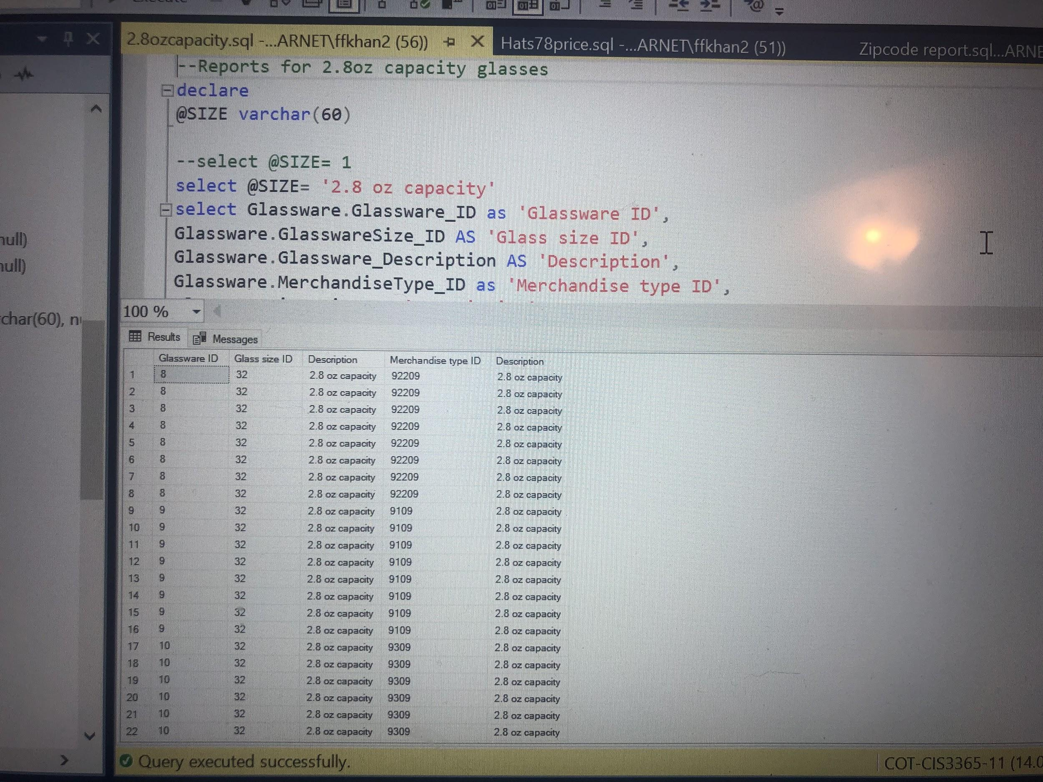

**Business Report 3**

**Report Name:** All Klaus Brewery Hats that are priced $78.

**Report Description**: This report gives good detailed information regarding all types and sizes of hats at Klaus Brewery that are on sale for $78.

**Business Purpose:** This type of reports will largely benefit our client in their products and sales management. This will assist them in analyzing and categorizing products individually based on their prices.

**SQL CODE**

--Report for hats with price of $78

declare

@PRICE float

select @PRICE= $78

select Hats.Hat_ID as 'Hat ID',

Hats.Hat_price as 'Price',

Hats.Hat_ColorID as 'Color ID',

Products.Brewery_ID as 'Brewery ID'

FROM PRODUCTS

JOIN dbo.Hats on HATS.Hat_price= Products.Product_Price

where Hats.Hat_price=@PRICE

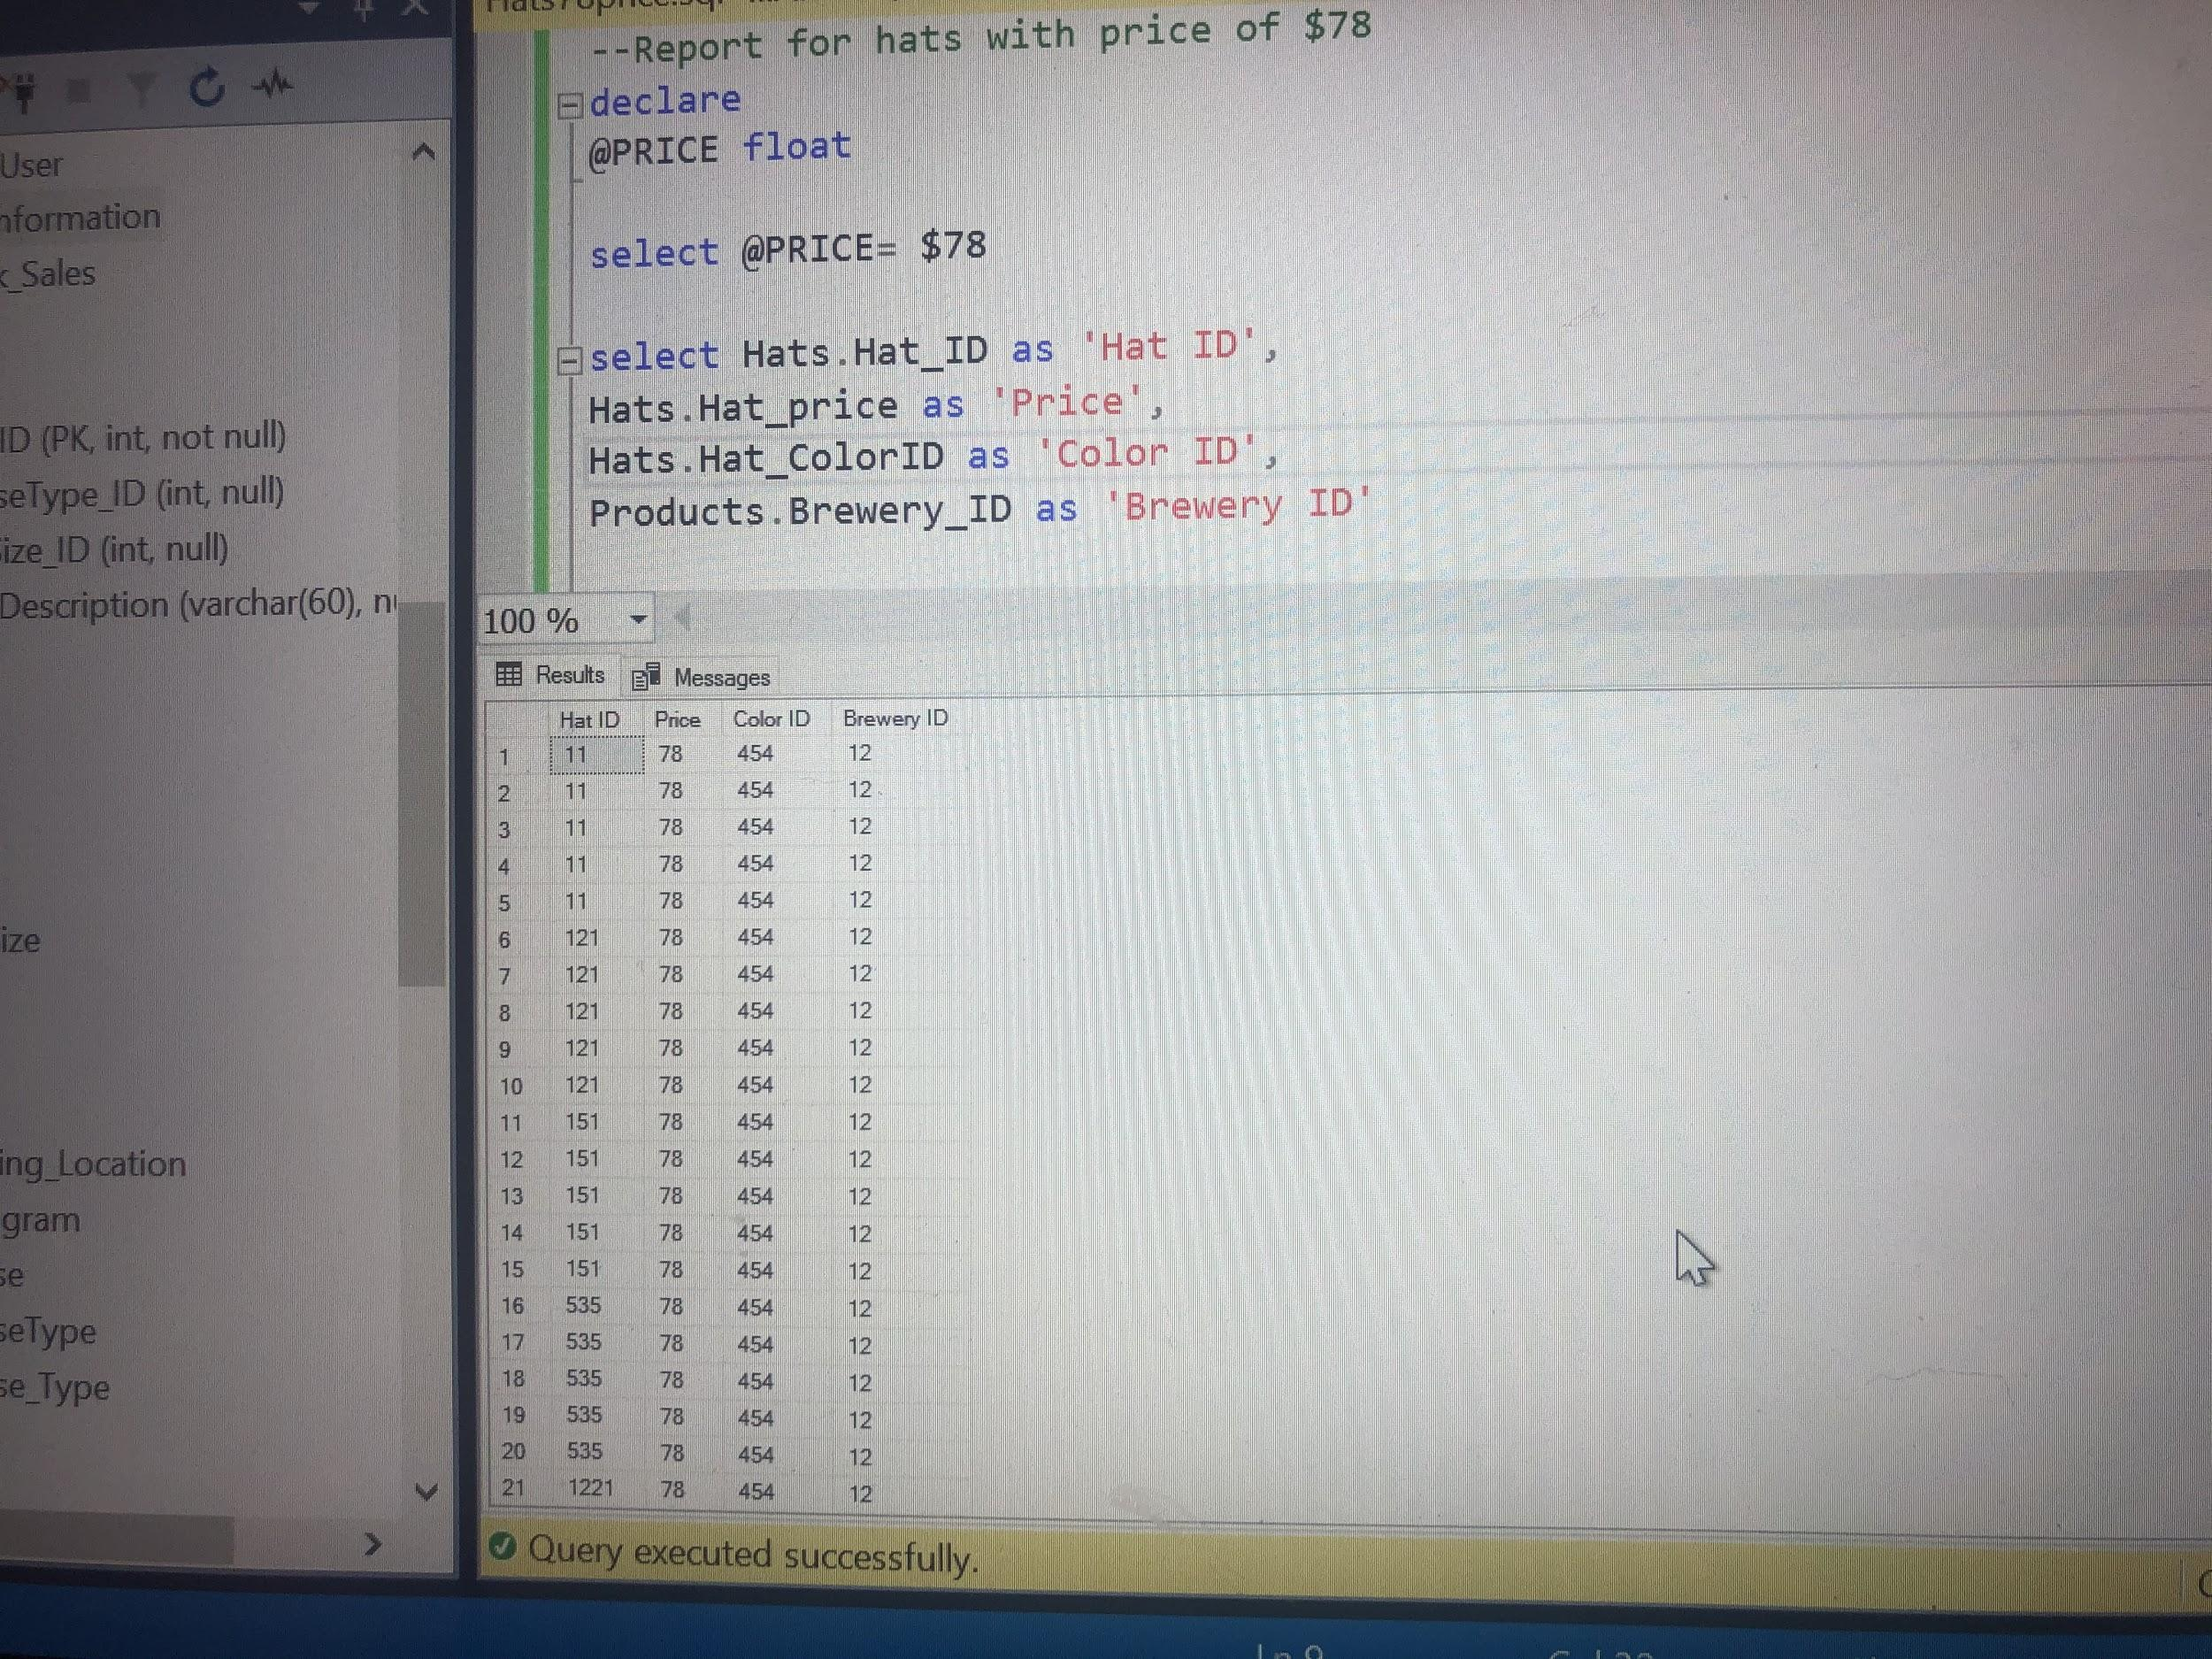

**Business Report 4**

**Report Name:** All Klaus Brewery employees located in the zip code 77871.

**Report Description**: This reports displays names , address and other valuable data regarding all employees of klaus that live in zip code 77871.

**Business Purpose:** This is a very beneficial report since it will help our client understand and better accommodate their employees in terms of their location. This will also be helpful in analyzing what employees can and cannot get to Brewery location in case of a flood or other natural disaster since this zip code is closer in proximity to brewery.

**SQL CODE**

--Report for employees located in the zip code 77871 only

declare

@emptable INT

select @emptable= 77871

select EmployeeInformation.Zip_Code AS 'Zip code for employee',

Zip_Code.Zip_Code_# AS 'Zip Code',

EmployeeInformation.First_name as 'First name',

EmployeeInformation.Middle_Initial as 'Middle',

EmployeeInformation.Last_name as 'Last name',

EmployeeInformation.City AS 'CITY',

Employee_Address AS 'ADDRESS'

FROM EmployeeInformation

JOIN dbo.Zip_Code on Zip_Code.Zip_Code_#= EmployeeInformation.Zip_Code

where Zip_Code.Zip_Code_#=@emptable

